**Mandzyuk Peter Mykhailovich**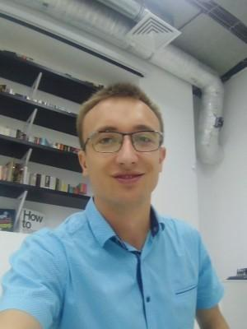

## Junior js developer

Full employment.

Age: 26

City: Кyiv

## Contact Information

Phone: 098 526-62-51

E-mail: petrom333@gmail.com

## Experience

### Junior/Trainee Frontend Developer

from 02.2020 to the present (5 months)  
Html academy, Kyiv (Education)

- Knowledge of HTML5, CSS3;  
- Adaptive and responsive layout, pixel perfect markup;  
- Strong understanding cross-browser compatibility;  
- BEM methodology (ability to write clean and reusable code);  
- JavaScript, ES6;  
- Advanced knowledge of Chrome DevTools and debugging;  
- Еxperience with version control systems (Git, GitHub);  
- Experience with graphics editor Photoshop;  
- Scrum;  
- Read technical documentation.

### Internet marketer

from 06.2018 to 01.2020 (1 year 7 months)  
“GALANT POL ELECTRA” ,Kyiv (Sales of electrical accessories in "B2B")

Duties:  
1. Implementation of CRM system in the company:  
- Full configuration of B24 for users, as well as: synchronization with 1C, IP telephony, connection of all advertising traffic channels;  
- Development of business processes in CRM;  
- Construction of sales funnels in CRM;  
- Automation of business processes in CRM.  
2. Analytics:  
- Construction of end-to-end analytics in the company;  
- Conducting analytics through advertising channels;  
- Conducting sales analytics.  
3. Email marketing:  
- Development of promotion strategy in Email Marketing;  
- Tool settings from 0;  
- Gaining audience loyalty;  
- Resuscitation of clients;  
- Increasing the number of applications.  
4. Creating sites:  
- One-page on website designer;  
- B2B portal.  
5. Conducting advertising campaigns in:  
- Adwords;  
- Facebook.  
  
  
Achievements:  
- Advertising strategy in "Digital direction";  
- Analytics of channel efficiency;  
- Successful email marketing;  
- Development a business portal for B2B customers;  
- Introduction CRM (B24) in the company with business process setup and integration with 1C, mail and IP telephony, automated application processing;  
- Automation of various business processes within the company, using 1C and CRM systems.

## Education

### NUBIP

Mechanal engineer, Kyiv  
Higher, from 10.2013 to 12.2016 (3 years 2 months)

Additional education

* Mate academy (2020, 2 місяці.)
* Html academy (2020, 3 місяці.)

**Professional and other skills**  
TECH SKILLS:  
  
- Programming Languages: JavaScript, HTML5, CSS3;  
  
- Frameworks: LESS(basic), Bootstrap;  
  
- Testing/Debugging: Chrome DevTools;  
  
- Other Windows tools: VS code, Git;  
  
- Experienced with Scrum and familiar with Agile.  
  
  
SOFT SKILLS:  
  
- Experience with technical documentation in English;  
  
- Communicative and able to work in the team;  
  
- Professional approach - compliance with rules and processes, Skrum methodology;  
  
- Ability to find and analyze information;  
  
- Positive thinking;  
  
- Ability to learn.  
  
  
MORAL AND BUSINESS QUALITIES:  
  
- Adequacy;  
  
- Attentiveness;  
  
- Purposefulness;  
  
- Responsibility.

## Language knowledge

* Ukrainian ─ free
* English ─ average
* Russian ─ above average